**JMeter Stress Testing**

Version 1.0

Prepared by Richard Ashman

ID:1342966

31/05/2019

**Table of Contents** **2**

Revision History 2

**Introduction** **3**

Aims 3

**Manual Test Cases** **3**

Case 1 3

Case 2 3

Case 3&4 3

Case 5&6 3

Case 7 3

Case 8 3

**JMeter Test Cases** **4**

Case 1 4

Case 2 5

**Discussion** **8**

**Links** **8**

Revision History

|  |  |  |  |
| --- | --- | --- | --- |
| Name | Date | Reason For Change | Version |
| Richard Ashman | 31/05/2019 | Release | V1.0 |
|  |  |  |  |
|  |  |  |  |

# Introduction

### Aims

This report is to document the testing of app.py using Python/Flask/Redis/Docker.

JMeter has been used for stress testing the application.

# Manual Test Cases

All tests are black-box tests unless otherwise stated.

## Case 1

- curl localhost:42966/isPrime/

Should not store any prime as it is not a recognised request.

## Case 2

- curl localhost:42966/isPrime/1

White-box test

Special edge case in the make isPrime method

Should return ‘1 is not prime” as 1 is not a prime number.

## Case 3&4

- curl localhost:42966/isPrime/2

Edge case as 2 is the first prime number

Should return “2 is prime”

- curl localhost:42966/primesStored

Black-box test

Should return the 2 that should have been stored from case 3

## Case 5&6

- curl localhost:42966/isPrime/4

Should return “4 is not prime” as 4 is not a prime

- curl localhost:42966/primesStored

Should not return the 4 from case 5

## Case 7

- curl localhost:42966/isPrime/5

Should return “5 is prime” as 5 is a prime

- curl localhost:42966/isPrime/4

Should return “4 is not prime” as 4 is not a prime

- curl localhost:42966/isPrime/17

Should return “17 is prime” as 17 is a prime

- curl localhost:42966/primesStored

Should return the 5 and the 17 but not the 4 (should also include a 2 from if test case 3 has been run)

## Case 8

curl localhost:42966/isPrime/2147483647

Should return “2147483647 is prime” as 2147483647 is a prime

- curl localhost:42966/primesStored

The last number returned should be 2147483647. (There might be more numbers if other tests have been run.

# JMeter Test Cases

## Case 1

2147483647 is checked to see if it is a prime. This is called using the app’s isPrime URL (/isPrime/<num>). This is done with 50 threads for 60 seconds.

This exact test was run twice. The first time this test was run the error count skyrocketed to 90% then spent the next minute slowly dropping.

Throughput stayed around 500/minute

looking into it showed that the app (redis) did a save of data.

This caused errors and displayed the following

redis_1 | 1:M 28 May 2019 22:40:41.070 * 100 changes in 300 seconds. Saving...

redis_1 | 1:M 28 May 2019 22:40:41.158 * Background saving started by pid 12

redis_1 | 12:C 28 May 2019 22:40:41.224 * DB saved on disk

redis_1 | 12:C 28 May 2019 22:40:41.225 * RDB: 0 MB of memory used by copy-on-write

redis_1 | 1:M 28 May 2019 22:40:41.259 * Background saving terminated with success

The second time the test was run produced no errors with the following info:

Samples Average Median 90% Min Max Error% Throughput (%) KB/sec

649 4863 5209 5902 53 6799 0.0 9.8111 1.6767

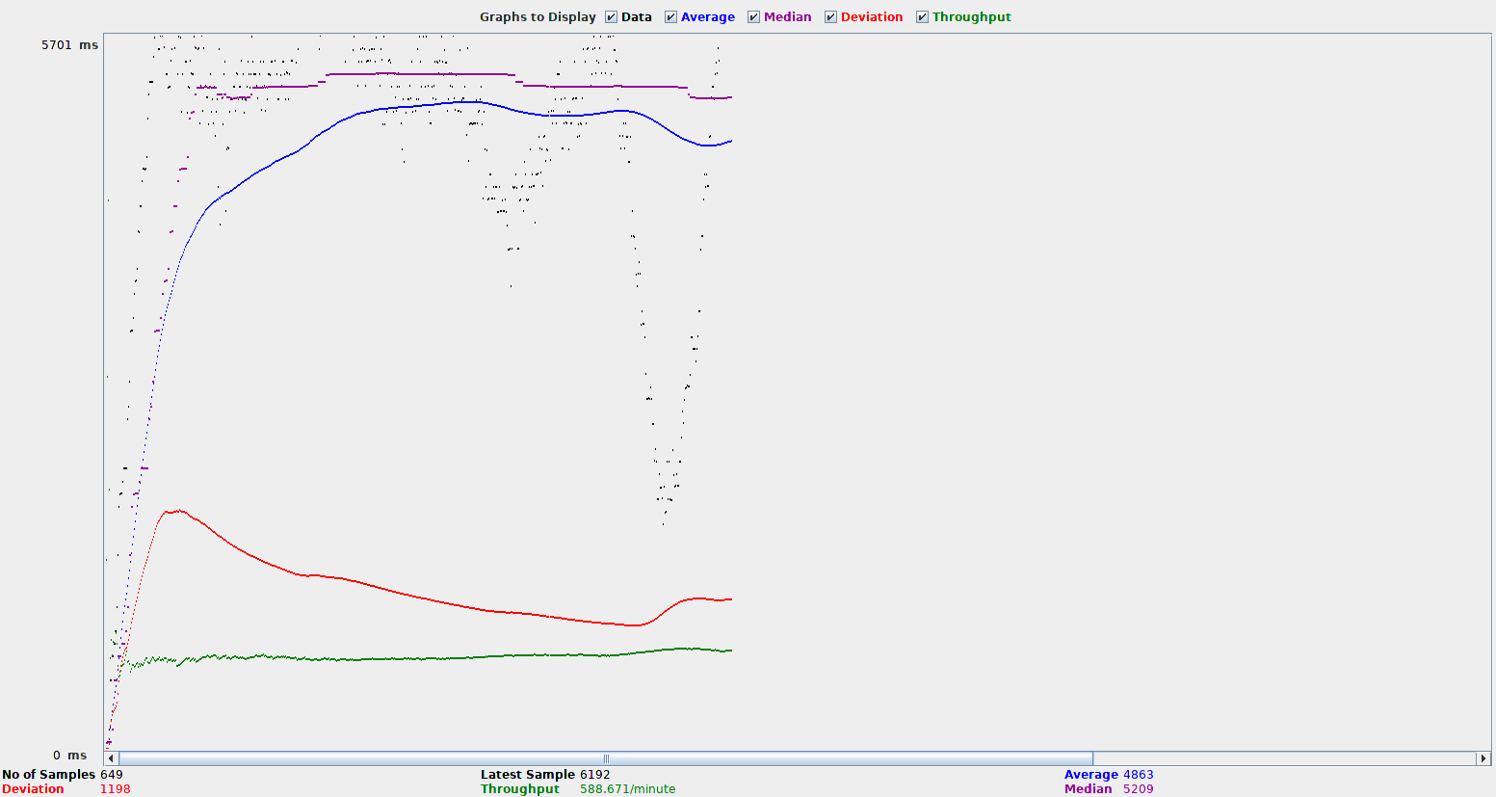

This was run again using 0.5 cpus (rather than 0.1) with the following results.

Samples Average Median 90% Min Max Error% Throughput (%) KB/sec

2450 1229 1315 1487 6 1788 0.0 40.2378 6.8765

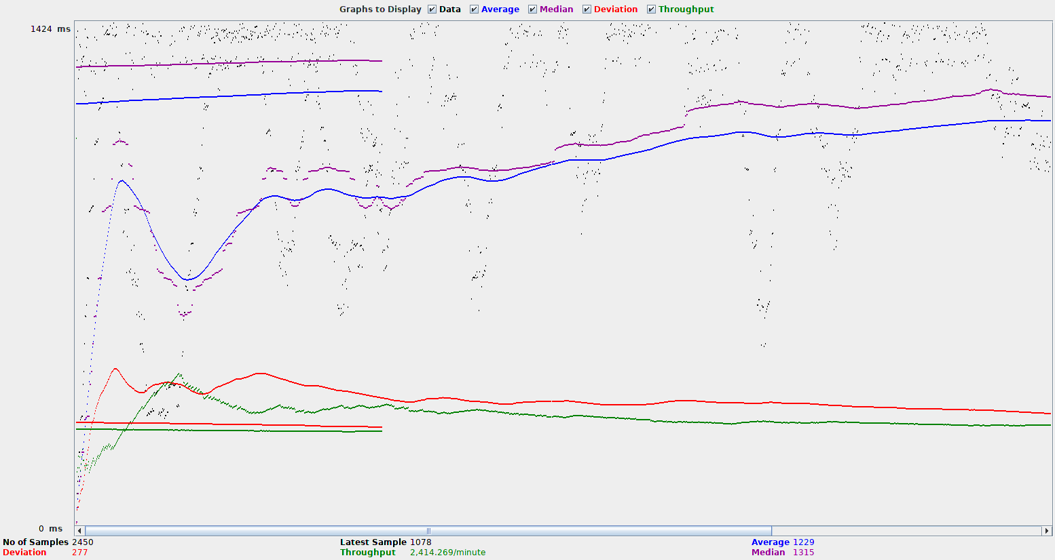

## 

## Case 2

isPrime is called for the numbers 1-100. Then primesStored is called for 60 seconds. Each of the 50 threads calls isPrime twice with the next number between 1-100 then all threads continue with the primesStored calls until the timer reaches 0.

This test was run first with a Ramp-Up Period (in seconds) of 0 and a Startup delay (seconds) of 0. The results were the following:

Samples Average Median 90% Min Max Error% Throughput (%) KB/sec

426 7174 7400 9206 2793 11300 0.0 6.3304 1.4525



This test was run second time with a Ramp-Up Period (in seconds) of 0 and a Startup delay (seconds) of 0. This time the cpus was changed from 0.1 to 0.5. It is clear to see when the first part (1-100) changed into the call to primesStpred. Using more of the cpu to stress test the system also started to cause errors. The results were the following:

Samples Average Median 90% Min Max Error% Throughput (%) KB/sec

1707 1752 1877 2190 91 3407 1.0 28.4073 12.4559

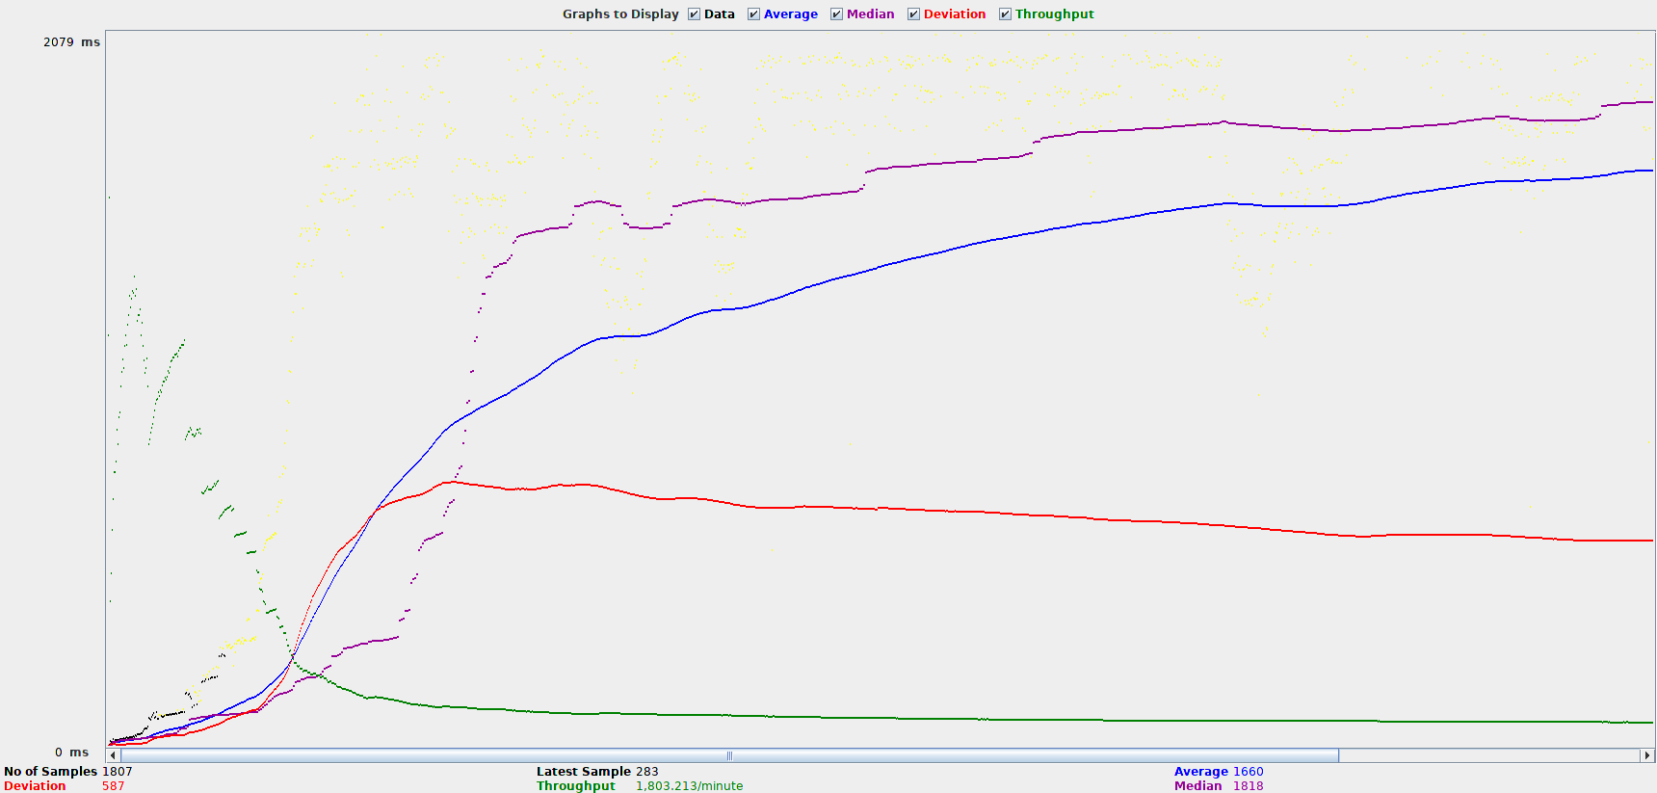

This test was run then run for a second time but with a Ramp-Up Period (in seconds) of 2 and a Startup delay (seconds) of 2. The results were the following:

Samples Average Median 90% Min Max Error% Throughput (%) KB/sec

416 7180 7500 8796 396 10196 0.0 6.1813 1.3533

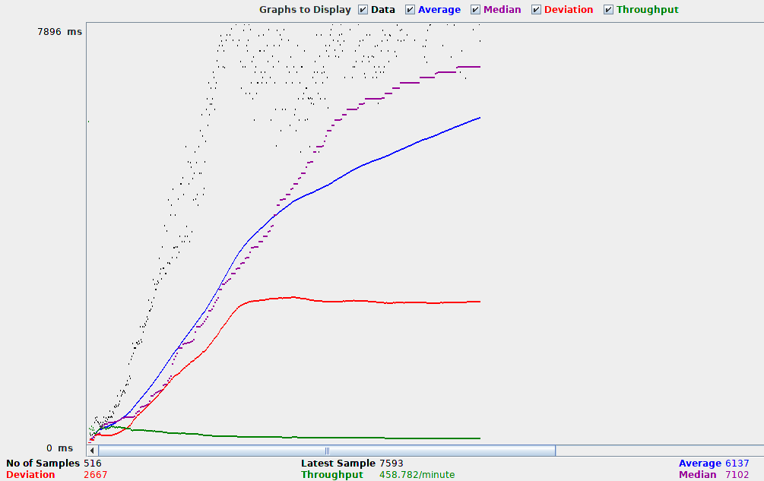

This test was run for a third time with the same 2 second delay but also using 0.5 cpus rather than 0.1 cpus.

Samples Average Median 90% Min Max Error% Throughput (%) KB/sec

3145 939 999 1614 4 2274 0.0 51.9036 11.3303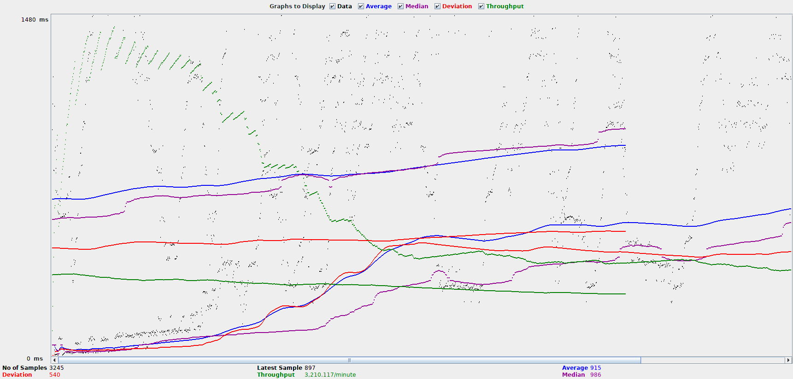

This test was run for a last time with the same 2 second ramp up period and using 0.9 cpus.

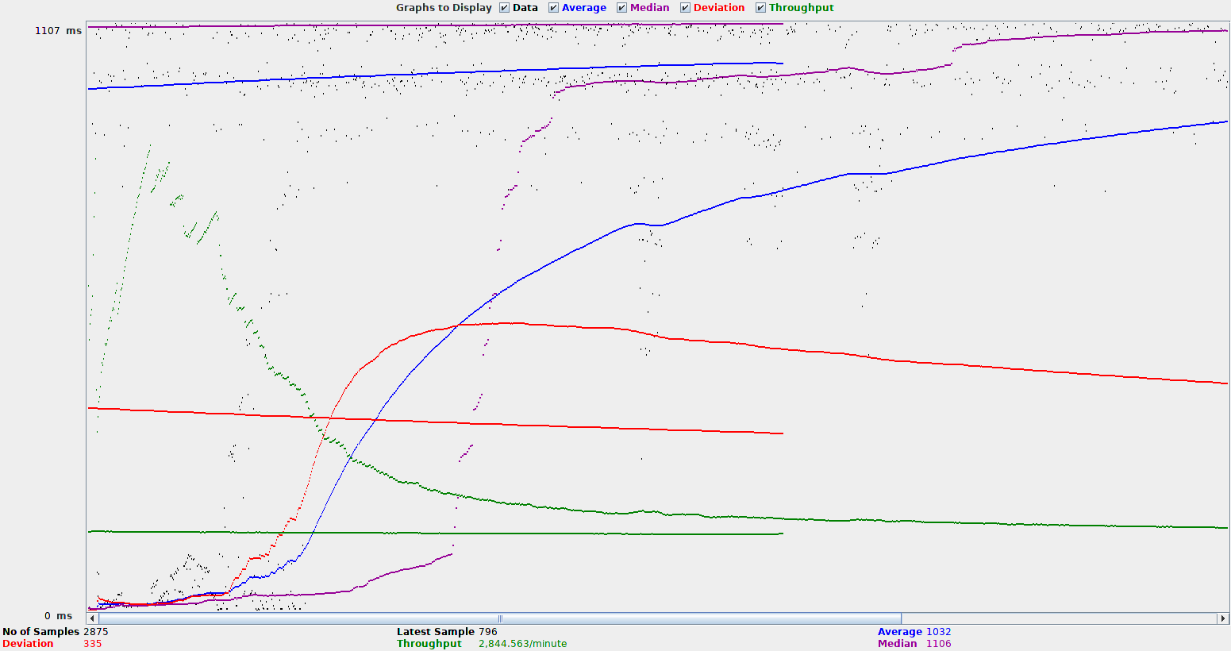

Samples Average Median 90% Min Max Error% Throughput (%) KB/sec

1623 1843 1995 2406 108 2795 0.0 26.4586 7.6880

# Discussion

There was a small issue with some errors when the cpus was ramped up to 0.5 cpus rather than 0.1 cpus but this later this did not show again even when the cpus were changed again. This was likely when the web service got increased without the redis service being increased. This would have caused an imbalance in the throughput that each service could handle. Potentially having the web service firing requests at the redis service when redis did not have the resources to complete the request.

The first large set of errors was caused by Redis saving but this did not always show up leading me to believe some changes in the redis configuration could have mitigated some of the delays caused.

This is a good result because having even when limiting the web app between 0.9 cpus and 0.1, JMeter still did not make many errors. A lot of the time JMeter got 0 errors.

# Links

GitHub: <https://github.com/RichardAshman/COMPX341-Assignment4>